
RAMAIAH
Institute of Technology
USN | 1 | M | S

(Autonomous Institute, Affiliated to VTU)
(Approved by AICTE, New Delhi & Govt. of Karnataka) Accredited by NBA & NAAC with ‘A’ Grade

EXAMINATIONS SEPTEMBER /OCTOBER 2020
SUPPLEMENTARY SEMESTER / GRADE IMPROVEMENT/ RE –REGISTERED CANDIDATES
Program | : | B.E.: Electrical and Electronics Engineering | Semester | : | VII
Course Name | : | Power Systems - II | Max. Marks | : | 100
Course Code | : | EE72 | Duration | : | 3 Hrs

Instructions to the Candidates:
- Answer one full question from each unit.
- Suitably assume any missing data.

 |  | UNIT- I
1. | a) | Write the Z_{bus} after adding branch 1 and 2 in the following network shown in Fig. 1(a) using Z_{bus} building algorithm. Branch 1 is connected between bus1 and 2.Branch 2 is connected between bus 1 and 3. Bus 1 is grounded and is the reference bus. 2Ω is the resistance of each branch.  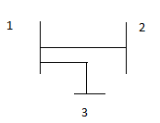  Fig. 1(a) | CO1 | (06)
 | b) | With neat sketch Model the 𝜋-equivalent circuit of transformers with off-nominal turns ratio used in formation of bus admittance matrix. | CO1 | (08)
 | c) | What are primitive element and primitive network? Mention an example for each. | CO1 | (06)
2 | a) | 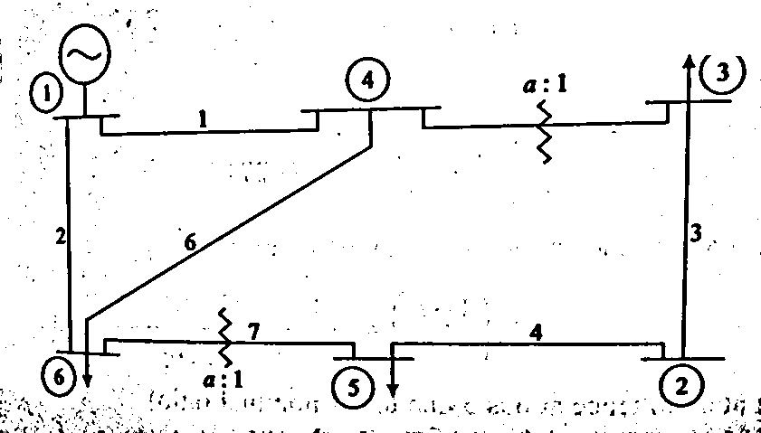  Fig. 2(a)  Consider the power system shown in Fig. 2(a) and corresponding data is given in Table 2.a. A static shunt capacitor is connected at bus 4 with admittance j0.005pu. Formulate the Y-Bus using inspection method. | CO1 | (10)
  Element | From-To Bus | Line impedance | Half line charging admittance | Off-nominal turn ratio.
  1 | 1-4 | 0.08+j0.37 | 0.007 | --
  2 | 1-6 | 0.123+j0.518 | 0.010 | --
  3 | 2-3 | 0.723+j1.05 | 0.0 | --
  4 | 2-5 | 0.282+j0.64 | 0.0 | --
  5 | 4-3 | 0.0+j0.133 | 0.0 | 0.909
  6 | 4-6 | 0.097+j0.407 | 0.0076 | --
  7 | 6-5 | 0.0+j0.3 | 0.0 | 0.976
 |  | Table 2.a
 | b) | Derive the step-by-step algorithm for formation of bus impedance matrix, when an element is added to the partial network is branch. | CO1 | (10)
 |  | UNIT- II
3. | a) | The line data and bus data of a 3-bus system is given below:  Line data  Bus data  Write the equations to be solved for the load flow solution using GS method. Obtain the voltages at the three buses at the end of two iterations using GS algorithm. | CO2 | (10)
  Line | Impedance  (pu)
  1-2 | j0.15
  1-3 | j0.23
  2-3 | J0.2
  Bus | PG(pu) | QG(pu) | PL(pu) | QL(pu) | Vsp(pu)
  1(slack) | - | - | - | - | 1.0
  2(PV) | 5.4 | - | - | - | 1.06
  3(PQ) | - | - | 6.0 | 0.54 | -
 | b) | Discuss the assumptions of fast decoupled load flow method. Derive the equations to be solved and show that the Jacobian need not be updated at every iteraiton. | CO2 | (05)
 | c) | What is a PV bus? What are the different methods available for controlling the voltage? Discuss the necessity of a slack bus. | CO2 | (05)
4. | a) | Draw the flow chart of the solution of load flow equations using GS method, including PV buses. | CO2 | (05)
 | b) | Given the bus admittance matrix as follows:  Ybus = 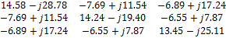  Bus 1 is slack bus with a voltage of 1.0 pu. Bus 2 is a PQ load bus with PL=5pu and QL=3.5pu. Bus 3 is a PV bus with a specified voltage of 1.02pu and PG=3pu. Form the Jacobian matrix and solve for the voltages using NR method for one iteration. | CO2 | (12)
 | c) | Justify the validity of decoupling the load flow equations. | CO2 | (03)
 |  | UNIT- III
5. | a) | A power system consists of two 100MW units whose input cost data are given by the equations  Rs/ Hour  Rs/ Hour  If the total received power is 150 MW,  - What would be the division of load between the units for the most economic operation?  - Find the savings per hour from economic operation as compared to equal sharing of load of 150 MW. | CO3 | (10)
 | b) | Derive an expression for transmission loss formula. | CO3 | (10)
6. | a) | With neat figures, explain the performance curves of generating units. | CO3 | (08)
 | b) | Calculate the required generation for each plant and power received by load when the system λ is Rs.25/MWh. If the 100MW is transmitted from plant 1 to load with a transmission loss of 10MW as shown in Fig. 6(b). Given the incremental fuel costs of two plants as:  dC₁/dP_{G1}=0.02P_{G1}+16  dC₂/dP_{G2}=0.04P_{G2}+20  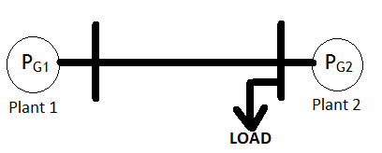  Fig. 6(b) | CO3 | (08)
 | c) | Distinguish between the problem of unit commitment and economic dispatch. | CO3 | (04)
 |  | UNIT- IV
7. | a) | Explain Milne’s predictor corrector method for solving swing equation. | CO4 | (10)
 | b) | Explain the modified Euler’s method used in the solution of swing equation under transient stability studies. | CO4 | (10)
8. | a) | Illustrate clearly the steps involved in solving swing equation using Runge- Kutta method for transient analysis. | CO4 | (10)
 | b) | At the beginning o a particular iteration in solution of swing equation, and rad/ sec. The mechanical power input =0.8 p.u. and the inertial constant M=0.0331 s²/ rad. If the maximum electrical power is 1.333p.u., determine the values of and , for the next 3 iterations using Runge- Kutta method, choosing step size of 0.02 sec. | CO4 | (10)
 |  | UNIT- V
9. | a) | Two generators rated 200MW and 400MW are operating in parallel. The drop characteristics of their governors are 4% and 5% respectively from no-load to full load. Assuming that the generators are operating at 50Hz at no load. How would a load of 600MW be shared between them? What will be the system frequency at this load? Assume free governor operation. | CO5 | (05)
 | b) | Write a brief note on FACTS controller. | CO5 | (05)
 | c) | Obtain the expression for change in steady state frequency deviation caused by changes in load demand. | CO5 | (10)
10. | a) | List the different compensation techniques and mention their advantages. | CO5 | (10)
 | b) | A 100 MVA synchronous generator operates on full load at frequency of 50 Hz. The load is suddenly reduced to 50 MW. Due to time lag in governor system, the steam valve beings to close after 0.4 seconds. Determine the change in frequency that occurs in this time. H=5kW-sec/kVA of generator capacity. | CO5 | (05)
 | c) | Write a short note on shunt compensator. | CO5 | (05)

****************

